**COSC2196**

**Introduction to information technology:**

**Assessment 1: My profile:**

**Personal information:**

Name: Cristian Fota

Student number: s3785541

Student email: [s3785541@student.Rmit.edu.au](mailto:s3785541@student.Rmit.edu.au)

Background information:

Nationality: Born in Australia with a Romanian background.

Education: Completed year 12 VCE and OUA applied mathematics.

Languages spoken: English, Romanian.

Other facts:

* Played tennis for 12 years
* Love gaming
* Own a cat named Levi
* Interested in business

**Interest in IT:**

What is your interest in IT? When did your interest in IT start?

* My interest in IT has always been there since I was a kid, with a deep interest and excitement for new and upcoming technology. I really started to find a passion for it when I built my first computer and also developed an interest for programming and creating applications. My main interest in IT is software development and creating application/ websites.

Was there a particular event or person that sparked your interest? Outline your IT experience:

* My passion for IT really began when my interest in Elon musk and other big programmers began. Seeing them create applications that create an impact on the world motivates me to want to do that same. My whole interest in IT increased exponentially when I built my first computer a few years ago.

Why did you choose to come to RMIT?

* I chose to come to RMIT because I feel like they really specialise in the technology/ IT sector as well as the actual campus is also really nice and inviting.

What do you expect to learn during your studies?

* I expect to gain a greater understanding in IT and slowly increase my skill set in the area. I also expect to learn how to work with people in teams and improve my communication skills.

**Ideal Job:**

<https://apply.workable.com/easy-go/j/1083D1A0A1/>

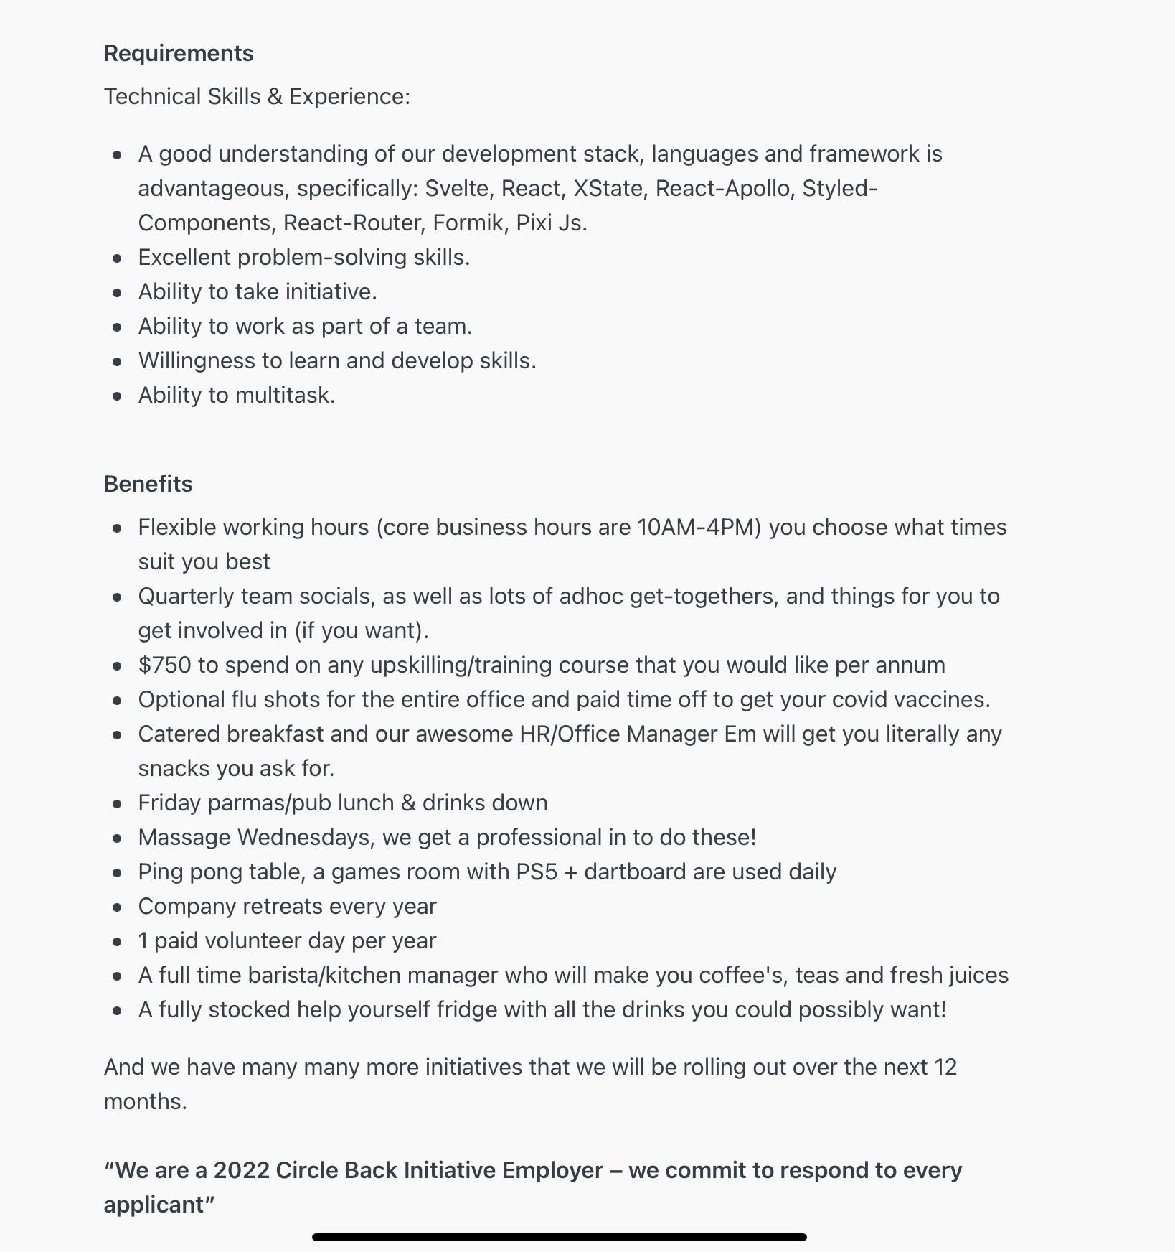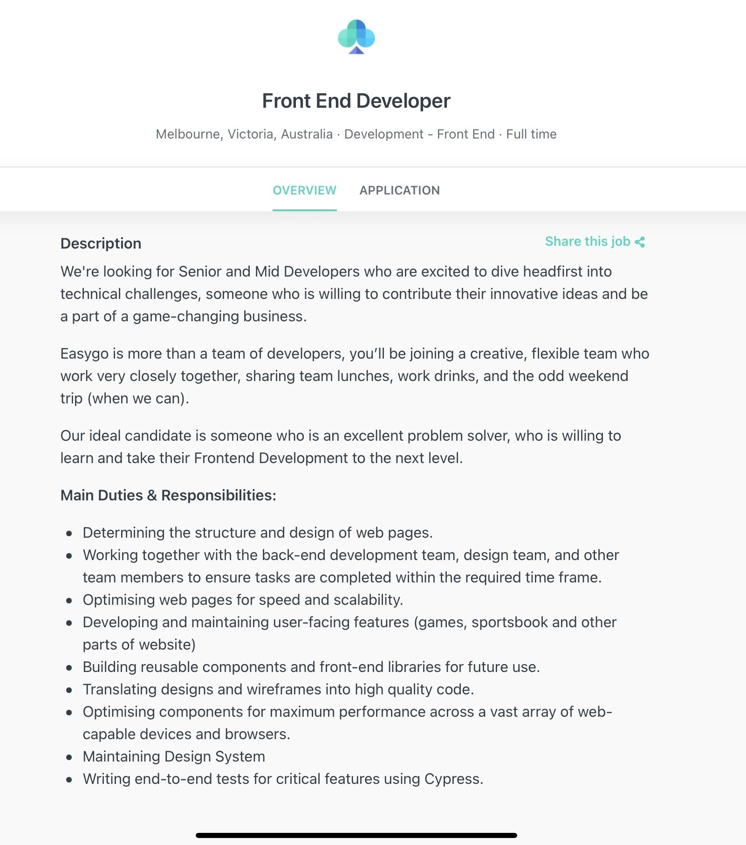

Description of the position:

* To build and develop the front end of applications/ websites that users are able to interact with. Specifically senior to mid developers that are able to contribute innovative ideas to a creative team of developers. Looking for someone who is a great problem solver and looking to take their front end development further.

Description of the skills:

* An understanding of our development stack, framework and languages. Good problem solving skills.
* Able to take initiative.
* Able to work as a team.
* Being able to multitask.

Description of my skills:

* I’m able to do very amateur programming and build computers.

Plan of how I will obtain the skills required for the position:

* I plan to continue and finish a few OUA IT and programming courses to then be able to get into a bachelor of computer science at RMIT to develop my skills further. Then after, find a job for experience and eventually try land a job at Easygo.

**Personal profile:**

*Results of an online Myers-Briggs test:*

* Personality type: Archilect
* Traits:
  + Introverted - 54%
  + Intuitive - 65%
  + Thinking - 54%
  + Judging - 60%
  + Turbulent - 56%
* Role: Analyst
* Strategy: Constant improvement

*Results of an online learning style test:*

* Scores:
  + Auditory: 10%
  + Visual: 30%
  + Tactile: 60%
* Therefore I'm a tactile learner meaning I learn by doing and touching and a hands on learner.

*Results of a Big 5 personality test:*

5 dimensions of personality:

1. Openness: 37.5%
2. Conscientiousness: 48%
3. Extraversion: 42%
4. Agreeableness: 37.5%
5. Neuroticism: 37.5%

What do all these results mean to you?

* It shows me that I like to discover new things and do whatever I do to the best of my ability as well as care for others and sometimes put them before myself. I think this is accurate and eye opening as well to me.

How do you think these results may influence your behaviour in a team?

* I think these results show that I’ll work well in a team in the sense of understanding others and their ideas as well as sharing and incorporating my own.

How should you take this into account when forming a team?

* I think you should take these results and find others similar in these personality and learning tests to then work better and more efficiently together. It will also create a better environment to work in if people are similar to yourself.

**PROJECT IDEA:**

Name: Appster

Overview:

Business owners and people alike want to create an application for their online business. Whether it's an application for their store or maybe a social business app where employees and people associated with the business communicate strictly for businesses. There’s only one problem, they have little to no experience in IT/software engineering and struggle to grasp the idea of creating an app so they resort to hiring experts. In doing so they spend a lot of their capital in hiring these experts as applications can be costly. Appster is an online application creation website that makes creating an app simply through pre-made templates.

Motivation:

In our day and age there is an increased demand in creating applications or websites for business and people alike. Today there are 1.85 million different apps available for people to download (Iqbal 2022) and over 6.3 billion smartphone users worldwide (BuildFire n.d.). Big businesses with large capital are able to hire experts to create applications for them although when it comes to small business they may not have the resources to do so. Appster makes this process easy and affordable for those small businesses. It will only require a small monthly subscription, then you create an app through our many premade templates.

Description:

Appster is an online website service that specialises in creating applications. It’s mainly aimed at small businesses and entrepreneurs with little to no capital. The main purpose of Appster is to allow small businesses to create applications for their business ecosystem and allow business related communication.

There will be 2 versions of Appster which will be:

* Appster mystore
* Appster business

These versions of Appster will be accessible when entering Appster for the first time. Upon opening Appster users will be greeted with 2 options:

1. Create a store.
2. Create a business communication app (still working on the name).

The first option (create a store) allows entrepreneurs with an existing or non-existing e-commerce store to create an application suited for their store. This allows outside users that are loyal customers to download it and purchase from the application rather than going on a search engine and going on their website.

The second option (business communication app) allows existing small businesses to create an app for their whole business ecosystem. When this app is created, it will allow co-workers and employees to communicate strictly for the small business and will also have work rosters, “employee fill in” chat sections etc. Everything involving the small business will be organised through this application which will allow the owner to easily manage and organise employees.

NOTE: users will be able to have both Appster mystore and Appster business if they have both subscriptions and can freely swap between versions of the website when needed.

There will be a small monthly subscription (including a 1 month free trial) users will be able to create applications for whatever purpose they desire and have other users be able to use them. There will be three subscription tiers with each increasing tier allowing for more creative features.

NOTE: Appster mystore will cost slightly more per month as there will be more detailed features and accessories available to use.

The user can create an app by editing the many pre-made application templates which can be customized to suit the owner’s needs. They can also create their own template with a simple drag and drop method. There will be 5 free templates to choose from and other more detailed templates coming at a one time cost.

Examples of possible ‘drag and drops’ can be a shopping cart to have users on the application go to when they check out of a store. Another example of a ‘drag and drop’ can be a chat room section for business where the user in the finished product can simply click that chat room icon on the app to go to an employee chat room.

There will also be integrated payment options to allow business with stores to allow in-app purchases from outside users.

Drag and drop options will depend on which version of Appster they are using (Appster mystore or Appster business).

Appster will allow users with programming and coding experience to edit code within the templates for even greater customisation.

Tools and technologies:

Software programs are needed to create Appster, specifically Adobe Dreamweaver. Adobe Dreamweaver is a website creation program that allows users to create webpages anywhere. It supports CSS, HTML, JavaScript and other languages. It’s able to build good looking sites that adapt to any device or browser and allows the user to create, code and manage dynamic websites simply with a smart coding engine. Adobe Dreamweaver allows the user to manage source code with Dreamweaver provided Git support as well (University of Denver n.d.).

Skills required:

The skills required for this project are:

* Problem solving skills.
* Knowing programming languages.
* Accuracy and attention to detail.
* Teamwork skills.
* Creative skill set.
* Experience in UI design.

It is likely possible to find people with some of these skill sets as there is an increased amount of potential workers in this industry especially with the increase in the popularity of software engineering and computer related interests etc.

Overview:

If this project is successful, there will be many users out there with their own applications suited for whatever businesses they are running. It will solve the original problem of small businesses having little to no resources and being unable to hire experts in creating custom applications for whatever their needs are. Now they can simply pay a small fee and have a quality app suited for themselves. The impact this development will have on small businesses and entrepreneurs will be large in the way that they are able to provide something more organised and atheistic to their loyal customers/ employees and create a tighter ecosystem of employees or customers with a low costing website.

References:

BuildFire n.d., *Mobile app download statistics and usage statistics (2022),* BuildFire, viewed 18 March 2022, <url>.

Iqbal, m 2022, *App Download Data (2022),* Business of Apps, viewed 18 March 2022, <url>.

University of Denver n.d., *Adobe Dreamweaver,* University of Denver, viewed 18 March 2022, <url>.